**Lightweight Overhead Monorail Conveyor Systems**

**NikoTrack's** overhead monorail conveyor systems are designed to suit most existing working environments. They can be configured as chain powered or a low cost alternative to 'power and free' systems for certain scenarios such as lean manufacturing systems. Automatic switches allow for side shifting on dual tracks to maximize storage space. NikoTracks six profiles are capable of carrying loads up to 3,520 lbs. **NikoTrack LLC** is a distributor of the Greek company Helm Hellas. Beginning in 1972, Helm Hellas originally focused on developing, producing and marketing sliding door fittings and overhead conveyor systems, but soon expanded to the light weight crane market as well. The **NikoTrack** product consists of a range of profile track sections, support fittings and carrier trolleys. These components can be assembled to produce a large range of modular design products including:

* Manual Overhead Conveyors
* Suspension Systems
* Festoon Cable Supply Systems
* Industrial Barn Door tracks and fittings
* Lightweight Overhead Cranes

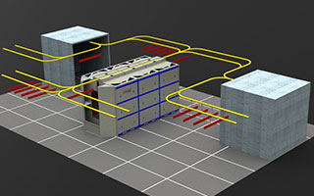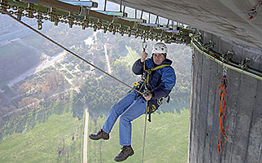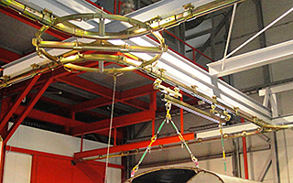

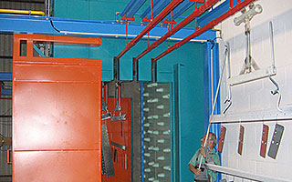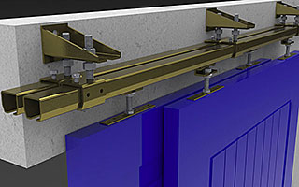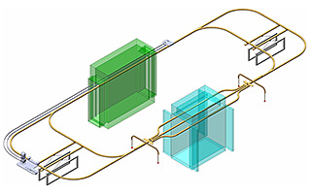

**NikoTrack Track Series**

**NikoTrack’s range of track series profiles are of compact design, and high quality.** NikoTrack is of cold rolled steel manufacture and supplied in standard 6 meter lengths in either plain, zinc plated, or stainless steel. Due to the design of the tapered sides this reduces the possibility of a build up of dust, thus assuring smooth running characteristics of the trolleys.

|  |  |  |  |  |
| --- | --- | --- | --- | --- |
| **Niko Profile** | **h (mm)** | **b (mm)** | **d (mm)** | **s (mm)** |
| No. 23.000 | 35.00 | 40.00 | 11.00 | 2.75 |
| No. 24.000 | 43.50 | 48.50 | 15.50 | 3.20 |
| No. 25.000 | 60.00 | 65.00 | 18.50 | 3.60 |
| No. 26.000 | 75.00 | 80.00 | 22.00 | 4.50 |
| No. 27.000 | 110.00 | 90.00 | 25.00 | 6.50 |

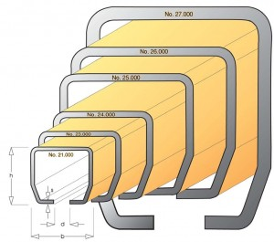

**NikoTrack Trolley Styles**

NikoTrack’s six profiles are immobile without their trolleys. **NikoTrack’s trolleys come in a variety of styles, all with different applications in mind**, most offered in every profile series, while some are specific to larger or smaller profiles.

*The trolleys pictured below are designated with partial part numbers. Each trolleys full part number is always prefixed with a track profile number (21, 23, 24 etc.)*

|  |  |  |  |  |  |  |
| --- | --- | --- | --- | --- | --- | --- |
| **TROLLEY SWL (Kg)** | | | | | | |
| **SERIES** | **21** | **23** | **24** | **25** | **26** | **27** |
| 2 Wheel | 10 | 20 | 40 | 100 | 200 | 400 |
| 4 Wheel | 20 | 40 | 80 | 200 | 400 | 800 |
| Flight Bar | 40 | 80 | 160 | 400 | 800 | 1600 |
|  | | | | | | |
| [C1 Conveyor System Catalog](http://nikotrack.com/wp-content/uploads/2012/11/C1-Conveyor-Catalog.pdf) | | | | | [C2 Technical Information and Component Specs](http://nikotrack.com/wp-content/pdfs/C2_Light_weight_Overhead_Cranes.pdf) | | |
| [C1 Conveyor Systems](http://nikotrack.com/wp-content/pdfs/C1_Overhead_Conveyors_Monorails.pdf) | | | | | [C2 Technical Information & Component Specs](http://nikotrack.com/wp-content/pdfs/C2_Light_weight_Overhead_Cranes.pdf) | | |

**[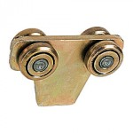](http://nikotrack.com/wp-content/uploads/2012/11/T00-lg.jpg)**

.T00   
customizable   
conveyor trolley

**[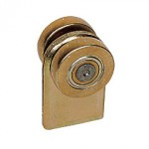](http://nikotrack.com/wp-content/uploads/2012/11/T01-lg.jpg)**

.T01   
two wheeled trolley

**[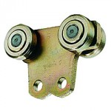](http://nikotrack.com/wp-content/uploads/2012/11/T07-lg.jpg)**

.T07   
two holed   
crane trolley

**[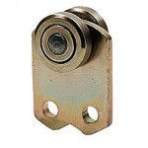](http://nikotrack.com/wp-content/uploads/2012/11/T08-lg.jpg)**

.T08

**[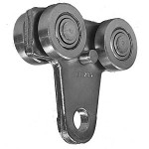](http://nikotrack.com/wp-content/uploads/2012/11/25.T10-lg.jpg)**

.T10

**[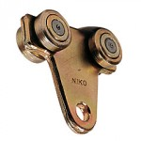](http://nikotrack.com/wp-content/uploads/2012/11/T10-lg.jpg)**

.T10   
four wheeled   
conveyor trolley

**[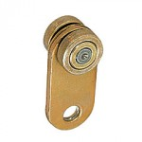](http://nikotrack.com/wp-content/uploads/2012/11/T11-lg.jpg)**

.T11 caption here

**[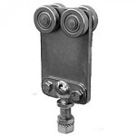](http://nikotrack.com/wp-content/uploads/2012/11/T12-lg.jpg)**

.T12

**[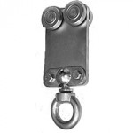](http://nikotrack.com/wp-content/uploads/2012/11/T13-lg.jpg)**

.T13

**[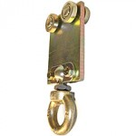](http://nikotrack.com/wp-content/uploads/2012/11/24.T13-lg.jpg)**

.T13

**[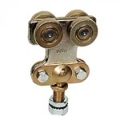](http://nikotrack.com/wp-content/uploads/2012/11/T14-lg.jpg)**

.T14   
conveyor trolley   
with swivel screw

**[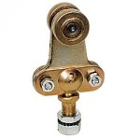](http://nikotrack.com/wp-content/uploads/2012/11/T15-lg.jpg)**

.T15   
double wheeled   
conveyor trolley   
with screw

**[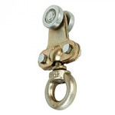](http://nikotrack.com/wp-content/uploads/2012/11/T19-lg.jpg)**

.T19   
ringed conveyor trolley

**[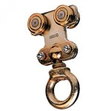](http://nikotrack.com/wp-content/uploads/2012/11/T20-lg.jpg)**

.T20   
looped four   
wheel trolley

**[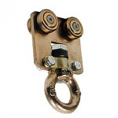](http://nikotrack.com/wp-content/uploads/2012/11/T40-lg.jpg)**

.T40   
reinforced   
looped trolley

**[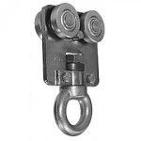](http://nikotrack.com/wp-content/uploads/2012/11/25.T40-lg.jpg)**

.T40   
reinforced looped trolley

**[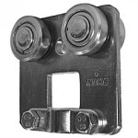](http://nikotrack.com/wp-content/uploads/2012/11/T41-lg.jpg)**

.T41   
reinforced plain   
four wheel trolley

**[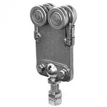](http://nikotrack.com/wp-content/uploads/2012/11/T42-lg.jpg)**

.T42   
screw joint four   
wheel trolley

**[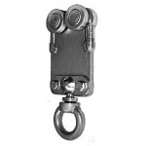](http://nikotrack.com/wp-content/uploads/2012/11/T43-lg.jpg)**

.T43   
swivel looped   
four wheel trolley

**[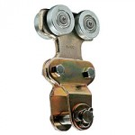](http://nikotrack.com/wp-content/uploads/2012/11/T44-lg.jpg)**

.T44   
hoist designed   
trolley crane

**[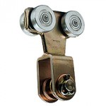](http://nikotrack.com/wp-content/uploads/2012/11/T46-lg.jpg)**

.T46   
trolley for hoist,   
crane trolley

**[](http://nikotrack.com/wp-content/uploads/2012/11/C1-Conveyor-Catalog.jpg)**

**NikoTrack Joints and Support Fittings**

**NikoTrack has a wide range of support methods in order to function in diverse work environments.**NikoTrack’s joints and support fittings come in a variety of styles all with different applications in mind, most offered in every track profile series, while some are specific to larger or smaller track profiles.

*The joints and support fittings pictured below are designated with partial part numbers. Each Fitting's full part number is always prefixed with a track profile number (21, 23, 24, etc.)*

|  |  |
| --- | --- |
| [C1 Conveyor System Catalog](http://nikotrack.com/wp-content/uploads/2012/11/C1-Conveyor-Catalog.pdf) | [C2 Technical Information and Component Specs](http://nikotrack.com/wp-content/pdfs/C2_Light_weight_Overhead_Cranes.pdf) |
| [C1 Conveyor Systems](http://nikotrack.com/wp-content/pdfs/C1_Overhead_Conveyors_Monorails.pdf) | [C2 Technical Information and Component Specs](http://nikotrack.com/wp-content/pdfs/C2_Light_weight_Overhead_Cranes.pdf) |

**[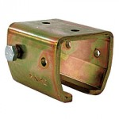](http://nikotrack.com/wp-content/uploads/2012/11/B00-lg.jpg)**

.B00   
Welded Ceiling Support

**[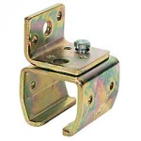](http://nikotrack.com/wp-content/uploads/2012/11/B01-lg.jpg)**

.B01   
Side Mounted Support   
for Conveyors

**[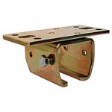](http://nikotrack.com/wp-content/uploads/2012/11/B02-lg.jpg)**

.B02   
Bolt on   
Crane Support

**[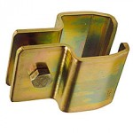](http://nikotrack.com/wp-content/uploads/2012/11/B03-lg.jpg)**

.B03   
Stalled Steel   
Support for Crane

**[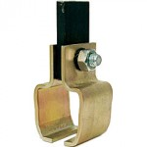](http://nikotrack.com/wp-content/uploads/2012/11/B03-On-lg.jpg)**

.B03   
Stalled Steel   
Support for Crane

**[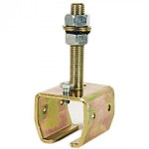](http://nikotrack.com/wp-content/uploads/2012/11/B04-Close-lg.jpg)**

.B04 Close   
Adjustable Bracket

**[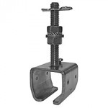](http://nikotrack.com/wp-content/uploads/2012/11/25.B04P-lg.jpg)**

.B04P   
Crane Adjustable Support

**[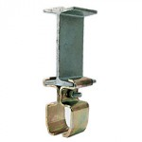](http://nikotrack.com/wp-content/uploads/2012/11/B08-On-lg.jpg)**

.B08   
Stalled Crane   
Steel Support Conveyor

**[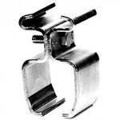](http://nikotrack.com/wp-content/uploads/2012/11/B08-lg.jpg)**

.B08 Stalled Crane Steel Support Conveyor

**[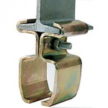](http://nikotrack.com/wp-content/uploads/2012/11/B08-Close-lg.jpg)**

.B08 Close   
Split Suspension   
Bracket

**[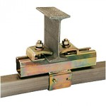](http://nikotrack.com/wp-content/uploads/2012/11/B35-lg.jpg)**

.B35 – .B36   
Combined Ceiling Bracket

**[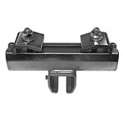](http://nikotrack.com/wp-content/uploads/2012/11/25.B35P-lg.jpg)**

.B35P   
ibeam Support Crane

**[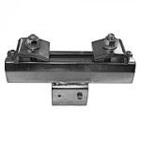](http://nikotrack.com/wp-content/uploads/2012/11/25.B36P-lg.jpg)**

.B36P   
ibeam Supported   
Crane Conveyor

**[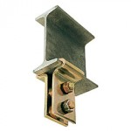](http://nikotrack.com/wp-content/uploads/2012/11/B40-lg.jpg)**

.B40

**[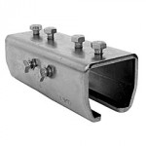](http://nikotrack.com/wp-content/uploads/2012/11/B49-lg.jpg)**

.B49   
Splice Joint

**[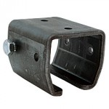](http://nikotrack.com/wp-content/uploads/2012/11/B50-lg.jpg)**

.B50   
Support for Crane   
or Conveyor

**[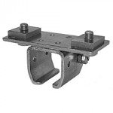](http://nikotrack.com/wp-content/uploads/2012/11/21.B62-lg.jpg)**

.B62   
Ceiling Mounted Crane

**[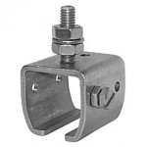](http://nikotrack.com/wp-content/uploads/2012/11/21.B64-lg.jpg)**

.B64   
Adjustable Ceiling Support

**[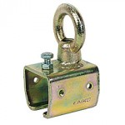](http://nikotrack.com/wp-content/uploads/2012/11/H09-lg.jpg)**

.H09

**[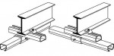](http://nikotrack.com/wp-content/uploads/2012/11/B35-B36-lg.jpg)**

.B35 – .B36   
Combined Ceiling Bracket

**[.B38](http://nikotrack.com/wp-content/uploads/2012/11/B38-lg.jpg)**

.B38

**[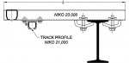](http://nikotrack.com/wp-content/uploads/2012/11/21.B60-lg.jpg)**

.B60   
Ceiling Mounted   
Conveyor Support

**NikoTrack Switches and Turn Fittings**

**NikoTrack’s ability to weave throughout a facility with their switches and turn fittings is what makes it so unique.** We offer 90, 60, 45, 30 angle bends. Each of these angles can be incorporated into an intersection switch, with 1-4 other tracks depending on the layout and switch assembly.

*The switches and turn fittings pictured below are designated with partial part numbers. Each Fitting's full part number is always prefixed with a track profile number (21,23,24, etc.)*

|  |  |
| --- | --- |
| [C1-Conveyor-Systems](http://nikotrack.com/wp-content/uploads/2012/11/C1-Conveyor-Catalog.pdf) | [C2 Technical Information and Component Specs](http://nikotrack.com/wp-content/pdfs/C2_Light_weight_Overhead_Cranes.pdf) |
| [C1 Conveyor Systems](http://nikotrack.com/wp-content/pdfs/C1_Overhead_Conveyors_Monorails.pdf) | [C2 Technical Information and Component Specs](http://nikotrack.com/wp-content/pdfs/C2_Light_weight_Overhead_Cranes.pdf) |

|  |  |
| --- | --- |
| **TRACK SERIES** | **SWL / FT** |
| No. 23.000 | 67.0 lbs |
| No. 24.000 | 134.0 lbs |
| No. 25.000 | 335.9 lbs |
| No. 26.000 | 671.9 lbs |
| No. 27.000 | 1075.0 lbs |
|  |  |

**[](http://nikotrack.com/wp-content/uploads/2012/11/A02-lg.jpg)**

.A02  
left turn switch  
for conveyor

**[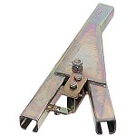](http://nikotrack.com/wp-content/uploads/2012/11/A05-lg.jpg)**

.A05  
tongue switch   
conveyor without bend

**[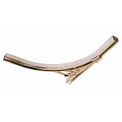](http://nikotrack.com/wp-content/uploads/2012/11/a11-lg.jpg)**

.A11  
conveyor tongue   
switch without   
bend conveyor

**[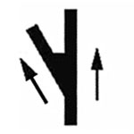](http://nikotrack.com/wp-content/uploads/2012/11/A12.jpg)**

.A12  
left turn with  
automatic tongue switch

**[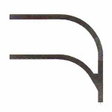](http://nikotrack.com/wp-content/uploads/2012/11/A22-lg.jpg)**

.A22  
automatic tongue switch  
left turns conveyor

**[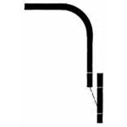](http://nikotrack.com/wp-content/uploads/2012/11/A30.jpg)**

.A30  
diagram of double swivel   
switch with left turn

**[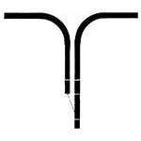](http://nikotrack.com/wp-content/uploads/2012/11/A32.jpg)**

.A32  
diagram of double swivel  
switch with turns L and R

**[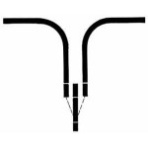](http://nikotrack.com/wp-content/uploads/2012/11/A34-lg.jpg)**

.A34  
triple swivel switch  
for conveyors

**[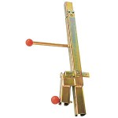](http://nikotrack.com/wp-content/uploads/2012/11/A36-lg.jpg)**

.A36  
single swivel switch  
for input / ouput of trolley  
on a conveyor

**[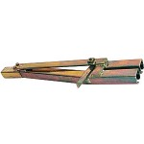](http://nikotrack.com/wp-content/uploads/2012/11/A38-lg.jpg)**

.A38  
double swivel switch  
for conveyors

**[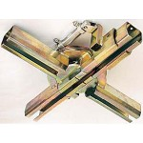](http://nikotrack.com/wp-content/uploads/2012/11/A40-lg.jpg)**

.A40

**[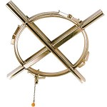](http://nikotrack.com/wp-content/uploads/2012/11/A41-lg.jpg)**

.A41  
large turntable switch  
for conveyors

**[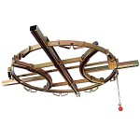](http://nikotrack.com/wp-content/uploads/2012/11/A43-lg.jpg)**

.A43  
multiple turntable switch  
with 2 bends on conveyors

**[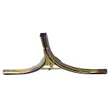](http://nikotrack.com/wp-content/uploads/2012/11/A47-lg.jpg)**

.A47  
double tongue switch   
with 2 integral bends   
on conveyor

**[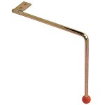](http://nikotrack.com/wp-content/uploads/2012/11/A50-lg.jpg)**

.A50  
conveyor manual  
switch handle

**[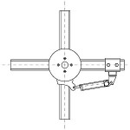](http://nikotrack.com/wp-content/uploads/2012/11/A64-lg.jpg)**

.A64  
drawing on  
pnumatic turntable

**[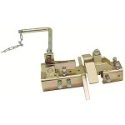](http://nikotrack.com/wp-content/uploads/2012/11/C16-H00-lg.jpg)**

.C16 – .H00  
crane transfer  
assembly crane

**[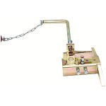](http://nikotrack.com/wp-content/uploads/2012/11/C16-H01-lg.jpg)**

.C16 – .H01  
transfer assembly  
switch crane

**[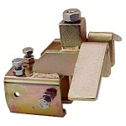](http://nikotrack.com/wp-content/uploads/2012/11/C16-H02-lg.jpg)**

.C16 – .H02  
transfer assembly  
receiver crane

**[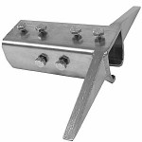](http://nikotrack.com/wp-content/uploads/2012/11/H04-lg.jpg)**

.H04  
transfer assembly  
simple crane

**[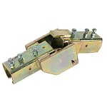](http://nikotrack.com/wp-content/uploads/2012/11/H08-lg.jpg)**

.H08

**[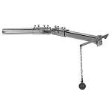](http://nikotrack.com/wp-content/uploads/2012/11/H15-lg.jpg)**

.H15

**[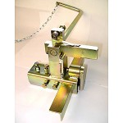](http://nikotrack.com/wp-content/uploads/2012/11/H21-lg.jpg)**

.H21  
BW transfer assembly  
for crane

**[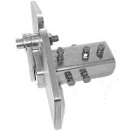](http://nikotrack.com/wp-content/uploads/2012/11/H22-lg.jpg)**

.H22  
transfer receiver joint  
for cranes

**[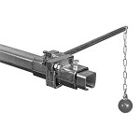](http://nikotrack.com/wp-content/uploads/2012/11/H60-lg.jpg)**

.H60 track transfer switch for cranes

**[](http://nikotrack.com/wp-content/uploads/2012/11/C1-Conveyor-Catalog-139.jpg)**

**NikoTrack Flight Bars**

**NikoTrack uses a flight bar to handle longer parts or part trees**. Flight bars mainly consist of two trolleys connected by a small length of track or steel. The trolleys commonly have a swivel ball joint to allow them to perform side steps in systems and take bends with ease. Most flight bars are custom built for a specific role, but we do offer standard assemblies.

*The flight bars pictured below are designated with partial part numbers. Each assembly's full part number is always prefixed with a track profile number (21, 23, 24, etc.)*

|  |  |  |  |  |  |  |
| --- | --- | --- | --- | --- | --- | --- |
| **TROLLEY SWL (Kg)** | | | | | | |
| **SERIES** | **21** | **23** | **24** | **25** | **26** | **27** |
| 2 Wheel | 10 | 20 | 40 | 100 | 200 | 400 |
| 4 Wheel | 20 | 40 | 80 | 200 | 400 | 800 |
| Flight Bar | 40 | 80 | 160 | 400 | 800 | 1600 |
|  | | | | | | |
| [C1 Conveyor System Catalog](http://nikotrack.com/wp-content/uploads/2012/11/C1-Conveyor-Catalog.pdf) | | | | | [C2 Technical Information and Component Specs](http://nikotrack.com/wp-content/pdfs/C2_Light_weight_Overhead_Cranes.pdf) | | |
| [C1 Conveyor Systems](http://nikotrack.com/wp-content/pdfs/C1_Overhead_Conveyors_Monorails.pdf) | | | | | [C2 Technical Information & Component Specs](http://nikotrack.com/wp-content/pdfs/C2_Light_weight_Overhead_Cranes.pdf) | | |

**[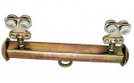](http://nikotrack.com/wp-content/uploads/2012/11/T24-lg.jpg)**

.T24   
Standard Flight Bar for Conveyor

**[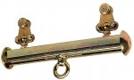](http://nikotrack.com/wp-content/uploads/2012/11/T25-lg.jpg)**

.T25   
Double Wheeled Conveyor Flight Bar

**[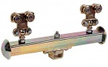](http://nikotrack.com/wp-content/uploads/2012/11/T32-lg.jpg)**

.T32   
Customized Conveyor Flight Bar Four Wheeled

**[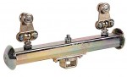](http://nikotrack.com/wp-content/uploads/2012/11/T33-lg.jpg)**

.T33   
Double Wheeled Customized Conveyor Flight Bar

**[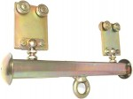](http://nikotrack.com/wp-content/uploads/2012/11/T64-lg.jpg)**

.T64   
Reinforced Conveyor Flight Bar